Dear lampworkers, flameworkers, glass bead makers and glass addicts ;-),

We need your valuable input in our decision making for 2016!

We would very much like to have Corina Tettinger here (from the USA, author of Passing the Flame) during March or April 2016, to present a few more classes – BUT you need to know what the costs might be AND we need to know how many people are interested and could commit themselves, otherwise it might not work either way.

I have already negotiated the rate and this is the best we could get, based on 6 people per day for 10 days. The cost will be US$200 (+VAT) per person per day. This includes the materials and use of our equipment in our studio plus lunch and refreshments.

We have compiled a list of possibilities for classes, most with pictures. What you need to do is to let us know which of these classes you would like to attend and can commit to by way of a deposit.  We can only go ahead with this if there is enough interest, so please get back to us asap! It will be appreciated if you could let us know by Friday 30 October 2015!

**Possibilities for classes**  
**A) 1 day - jumpstart: basic shaping, pulling stringer, applying dots, creating patterns, poking, twisting, raking dots**

**(sorry no picture)**

**B) 1 day - solving the stringer mystery**

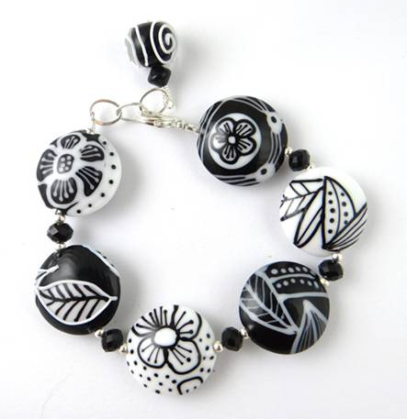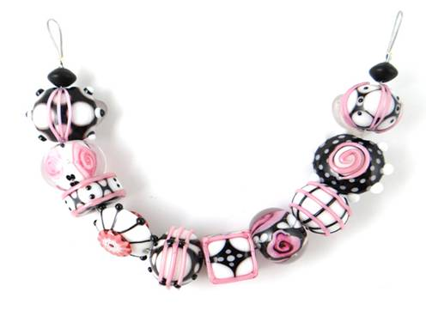  
  
**C) 1 day - fossil beads: putting it all together, making twisties, goldstone stringer, simple murrini cane**

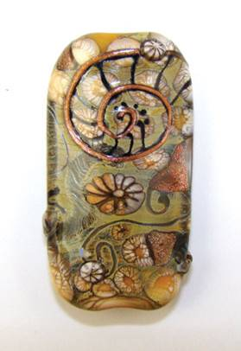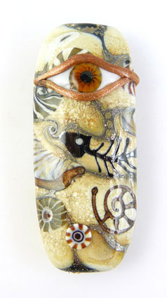

**D) 1 day - caterpillar encasing, big blob encasing, diagonal encasing of a variety of designs  
(sorry no picture)**

**E) 1 day - basic encased florals, shaping petals, making stamen cane, vine cane**

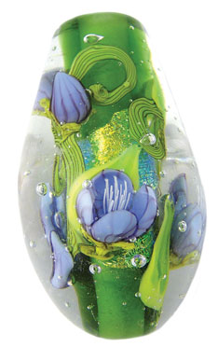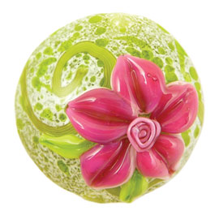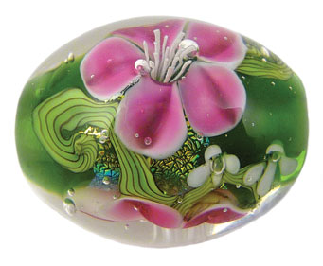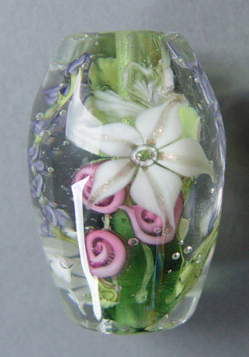

**F) 1 day - complex florals, raised stamen cane, tiger lilies, poppies, florals depend on the desire of the students**

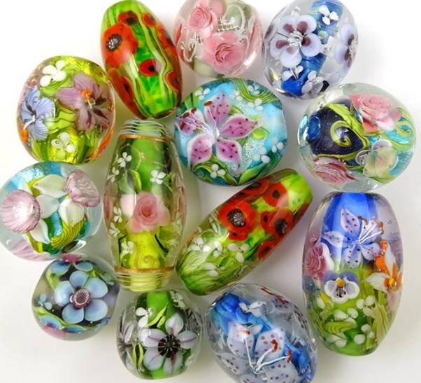

**G) 1 day - rainforest beads, variety of leaves, butterflies, birds – surface decoration.**  
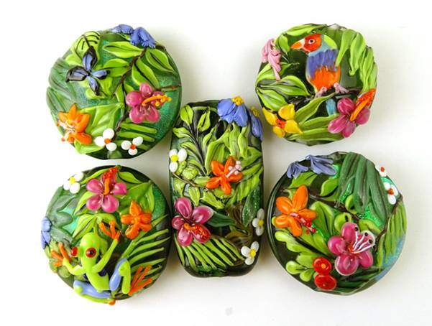

**H) 1 day - rainforest beads, variety of leaves, butterflies, birds – encased.**

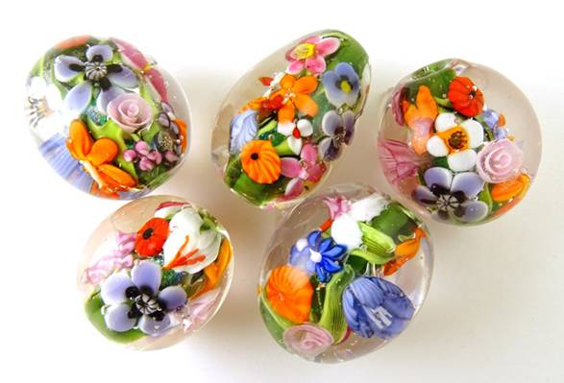

**I) 1 day - ocean creatures: starfish, jelly fish, turtle, crab, ribbon fish**

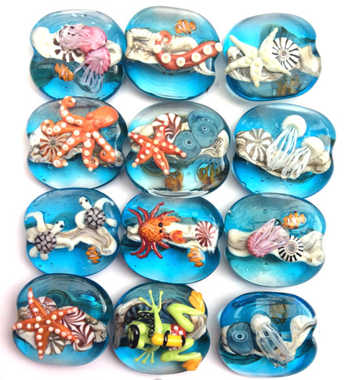

**J) 2 days: ocean beads, 1st day making variety of ocean themed murrini and seaweed cane, 2nd day making surface decorated bead and encased reef bead**

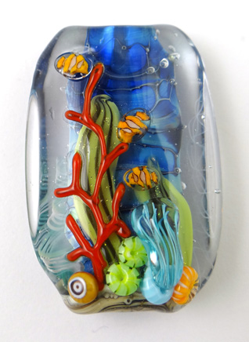

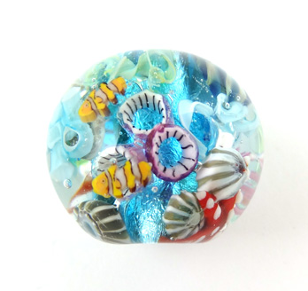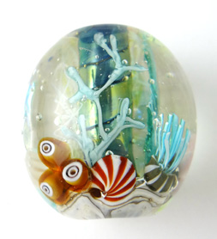

**K) 1 day (can be mised in anywhere): frogs and lizards**

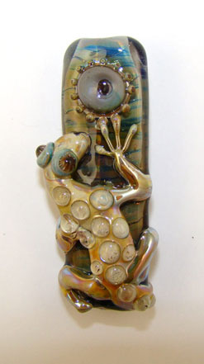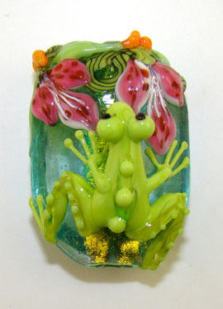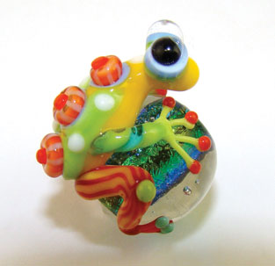

**L) 1 day: Painted nature**

